Objective 4  
Analysis 4.1 To investigate the influence of floor level on rental price  
Analysis 4.1.1 Which floor types has the highest impact on the rental price?

Based on the analysis, the Lower Floor rental prices are relatively low. The Medium Floor rental prices are relatively higher than Lower Floor. The Upper Floor rental prices are relatively higher than Medium Floor. According to the linear regression model, the coefficients for Medium Floor and Upper Floor are 54433.2 and 126676.4 showing have higher rental price compared to Lower Floor. The floor that has the highest impact is the Upper Floor. The model explains about 36.02% of the variance in rental price. There might be other factors affecting rental price.

Analysis 4.1.2 How do different types of floors affect the rental prices based on whether the properties are furnished or not?

Based on the analysis, floor category and furnishing status are significant predictors of rental prices. According to the linear regression model unit from medium floors and upper floors has range of 48861 and 52999 price impact compared to units from lower floors, while the furnished and unfurnished has range of -19241 and -30550 lower than the semi-furnished units. This means that Upper Floor and Semi-furnished has the highest impact of the rental price. The model explains about 18.89% of the variance in rental price. There might be other factors affecting rental price.

Analysis 4.1.3 How does floor categories relate to rental prices based on the area size?

Based on the analysis, floor category and area size are significant predictors of rental prices. According to the linear regression model unit from medium floors and upper floors has range of 47015 and 1404437 price impact compared to units from lower floors, while the small areas and medium area has range of -114516 and -95041 lower than the large areas. This means that the Upper Floor and Large Area has the highest impact of the rental price. The model explains about 36.07% of the variance in rental price. There might be other factors affecting rental price.

Analysis 4.1.4 Which of the top three factors based on furnishing status, floor, and area size had the highest impact on rental price?

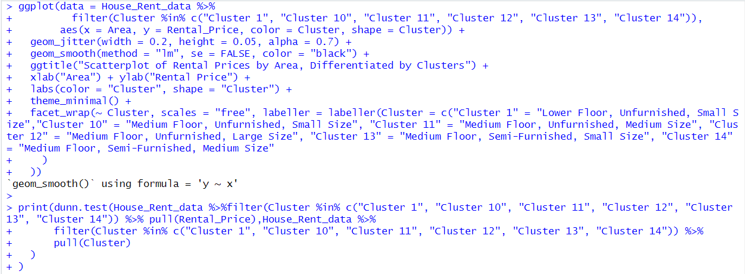

Based on my analysis, I have compared and filtered all the possible clusters with respect to floor category, furnishing status, and area size. After comparing all the clusters, I have picked the ones that have the most obvious impact on rental price. The chart clearly shows that the rental prices are increasing for all factors. According to Kruskal-Walli’s rank sum test and multiple comparison tests. The testing shows that there are significant differences rental prices between all clusters because the p-value is 0. Based on the p-values, it seems like Cluster 1 and Cluster 10 have the highest impact on the rental price because both clusters have extremely low p-values. In conclusion, Cluster 11 (Medium Floor, Unfurnished, and Small Size) has a significant impact on rental price, followed by Cluster 1 (Lower Floor, Unfurnished, and Small Size).

Analysis 4.1.5 Did the rental price in Kolkata City have an impact due to factors such as furnishing status, floor, and area size?



Based on my analysis and according to the ANOVA results, furnishing status and area size both had a statistically significant impact on rental price in Kolkata City. The p-value for Area is less than 0.0000000000000002 and there is a strong relationship between the area size and rental price. Secondly, the p-value for Furnishing Status is 0.00628 also showing there is also a significant relationship between the furnishing status and the rental price. However, the p-value for Floor Category is 0.46641 and there is no significant relationship between the floor category and the rental price. This could be because Kolkata only has lower floors (basement, upper basement, and floors 1 to 10) and medium floors (floors 11 to 20), with no upper floors (21 and above). In conclusion, even though the analysis may not accurately represent the impact of floor category on rental prices, it does show that factors such as furnishing status and area size have a significant impact on rental prices in Kolkata.

Analysis 4.1.6 Did the rental price in Mumbai City have an impact due to factors such as furnishing status, floor, and area size?

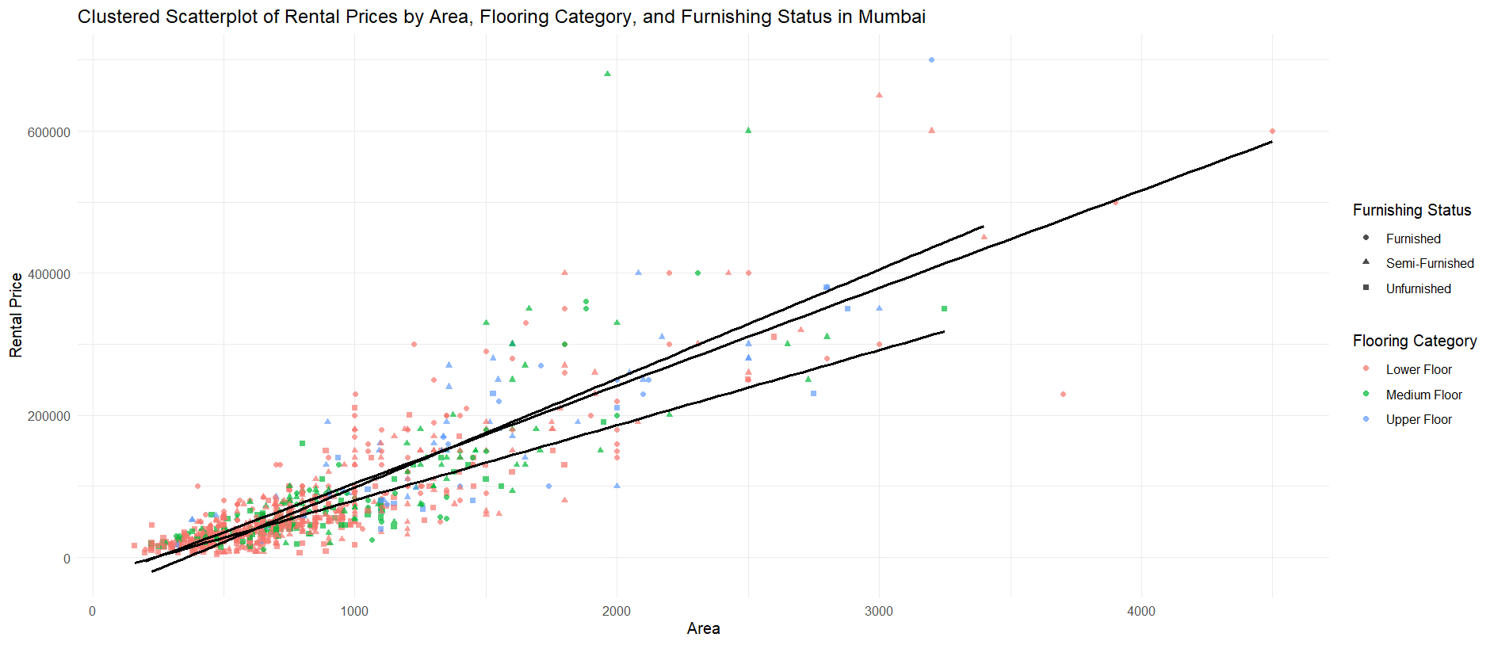

Based on my analysis and according to the ANOVA results that Floor Category, Furnishing Status, and Area all had a statistically significant impact on rental price. The p-value for Floor Category and Area is less than 0.0000000000000002 and showing that the 2 factors have a strong relationship with the rental price. Moreover, the p-value for furnishing status is 0.000223 also showing that there is significant relationship between the furnishing status and the rental price. In conclusion, all 3 factors have an impact on rental prices in Mumbai City.

Analysis 4.1.7 Did the rental price in Bangalore City have an impact due to factors such as furnishing status, floor, and area size?

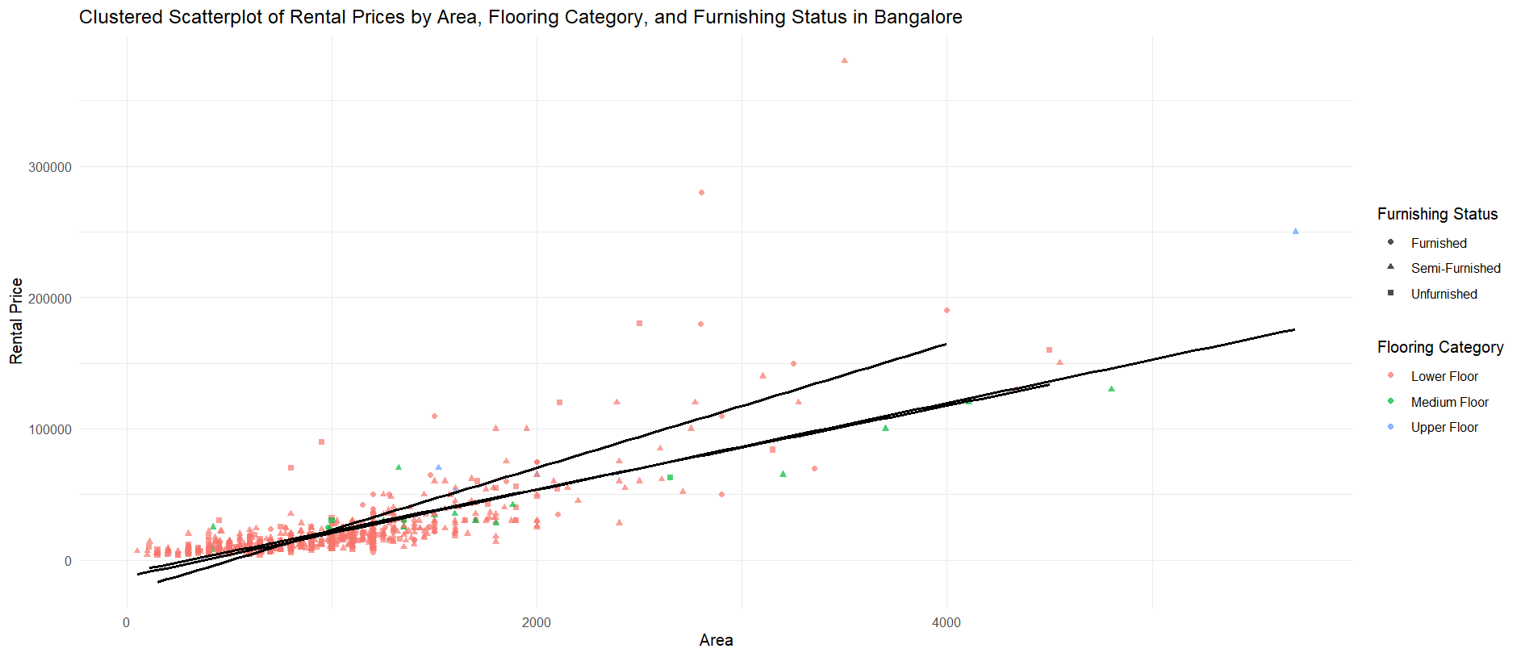

Based on my analysis and according to the ANOVA results that Floor Category, Furnishing Status, and Area all had a statistically significant impact on rental price. The p-value for Floor Category and Area is less than 0.0000000000000002 and showing that the 2 factors have a strong relationship with the rental price. Moreover, the p-value for Furnishing Status is 0.00992, also showing that there is significant relationship between the furnishing status and the rental price. In conclusion, all 3 factors have an impact on rental prices in Bangalore City.

Analysis 4.1.8 Did the rental price in Delhi City have an impact due to factors such as furnishing status, floor, and area size?

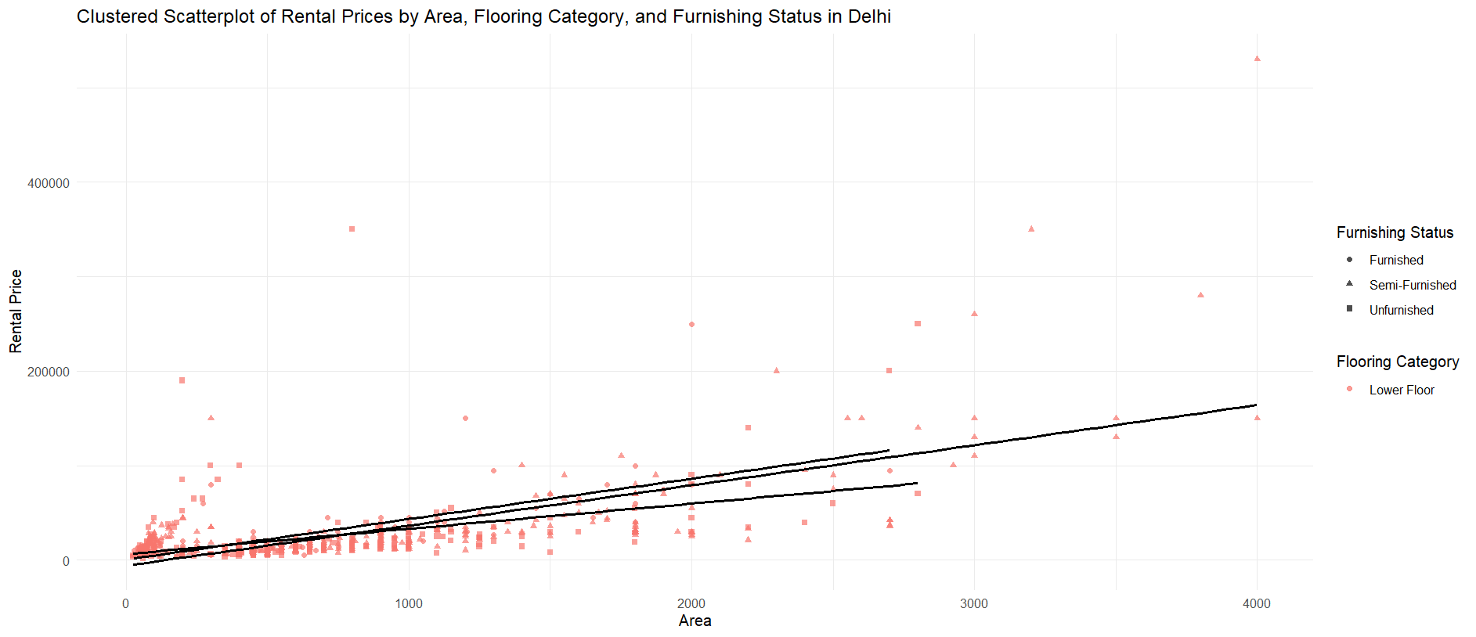

Based on my analysis and according to the ANOVA results, Area had a statistically significant impact on rental price in Delhi City. The p-value for Area is less than 0.0000000000000002 and there is a strong relationship between the area size and rental price. However, the p-value for furnishing status is 0.358, which means there is no significant relationship between furnishing status and rental price in Delhi city. Since the highest floors in Delhi city are 10 floors, which is the lower floor, with no medium floors (floors 11 to 20) or upper floors (21 and above), this could be a potential weakness in the analysis. In conclusion, even though the analysis may not accurately but based on observations that the area size has a significant impact on rental prices in Delhi City.

Analysis 4.1.9 Did the rental price in Chennai City have an impact due to factors such as furnishing status, floor, and area size?

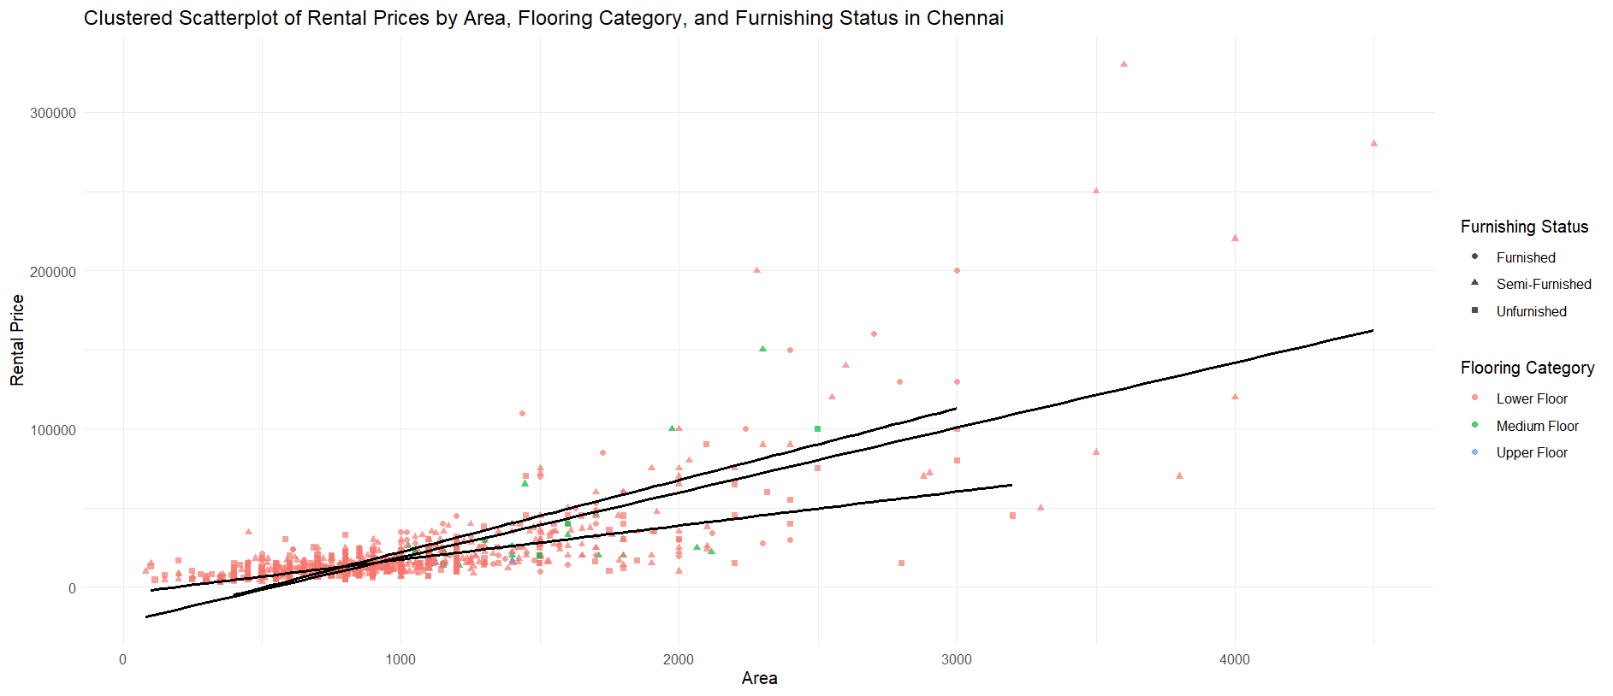

Based on my analysis and according to the ANOVA results, floor category and area both had a statistically significant impact on rental price in Hyderabad City. The p-value for Floor Category is less than 0.000033 and there is a strong relationship between the floor category and rental price. Secondly, the p-value for the Area is also less than 0.0000000000000002 and showing there is also a significant relationship between the area size and the rental price. However, the p-value for Furnishing Status is 0.0512 and there is no significant relationship between the furnishing status and the rental price in Hyderabad city. In conclusion, even though furnishing status did not have a significant impact, both floor category and area have an impact on rental prices in Chennai City.

Analysis 4.1.10 Did the rental price in Hyderabad City have an impact due to factors such as furnishing status, floor, and area size?

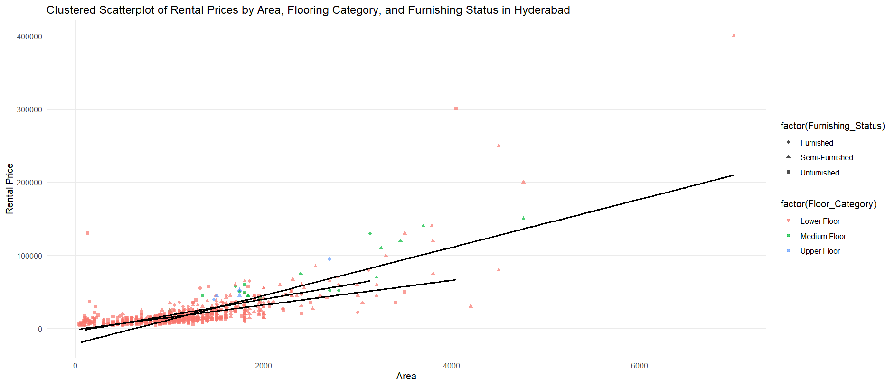

Based on my analysis and according to the ANOVA results, floor category and area both had a statistically significant impact on rental price in Hyderabad City. The p-value for Floor Category is less than 0.0000000000000002 and there is a strong relationship between the floor category and rental price. Secondly, the p-value for the Area is also less than 0.0000000000000002 and showing there is also a significant relationship between the area size and the rental price. However, the p-value for Furnishing Status is 0.301 and there is no significant relationship between the furnishing status and the rental price in Hyderabad city. In conclusion, even though furnishing status did not have a significant impact, both floor category and area have an impact on rental prices in Hyderabad City.

* 1. Extra Features

1. options(scipen = 999) – Extends the number of lines of the results
2. geom_jitter() -
3. geom_smooth() -
4. labs() -
5. scale_fill_gradient() – Fill color for plot elements,
6. xlab() – To add a label to the x-axis
7. ylab() – To add a label to the y-axis
8. theme_minimal() - Sets the overall theme of the plot to a minimal style
9. theme() – Used to customize various aspects of the plot’s appearance
10. lm – Helping to understand how much a range impacts the rental price
11. dunn.test() – Used to perform post hoc comparisons of all clusters
12. aov() -
    1. Conclusions